# *QUESTION BANK*

# Need of Question Bank:-

## Coding of create a Question Bank Web Application

|  |
| --- |
| 1. Set Frame |
| <html> | <head> |
|  | <title>Frameset_ college</title> |
|  | </head> |
|  | <frameset rows="30%,10%,50%,10%"> |
|  | <frame name="" src="College heading.htm"> |
|  |  |
|  | <frame name="" src="Question bankTitle college.htm"> |
|  | <frameset cols="20%, 60%, 20%"> |
|  | <frame name=" "src="marquee College.htm"> |
|  | <frame name=""src="BCA All sem Heading.htm"> |
|  | <frame name="" src="marquee College notice.htm"> |
|  | </frameset> |
|  | <frame name="" src="Developed by heading.htm"> |
|  | </frameset> |
|  | </html> |

## Output:-

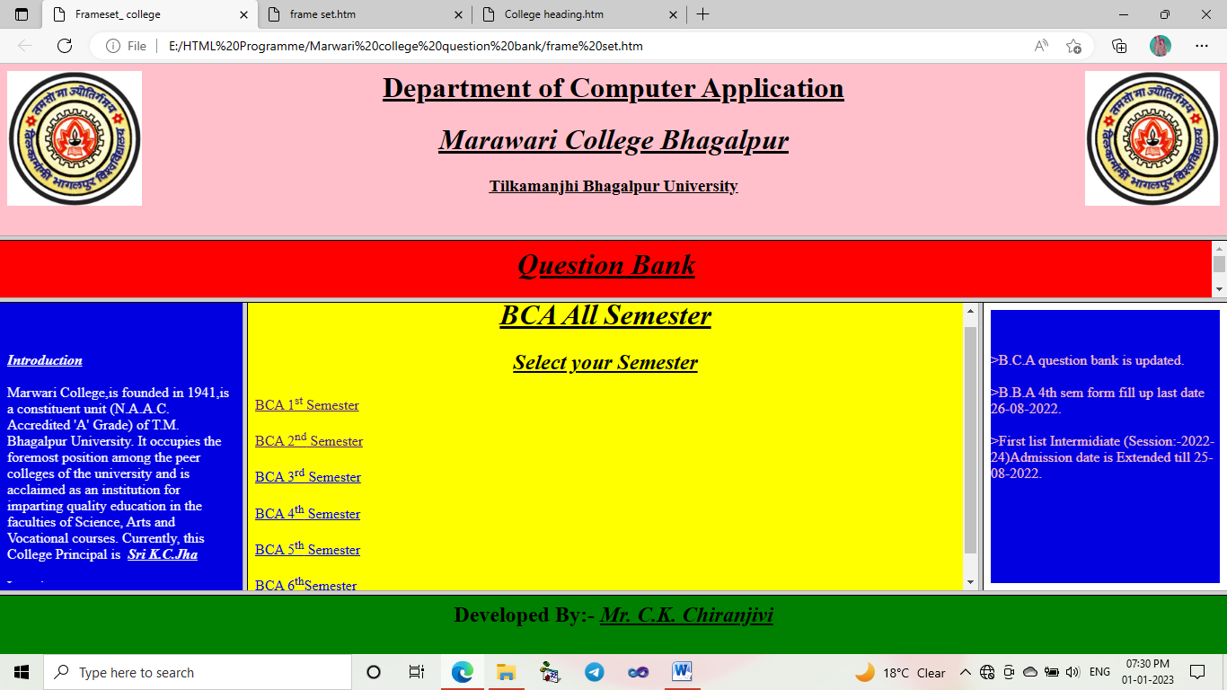

## 2. Coding and Designing of College Heading :-

|  |  |
| --- | --- |
|  | <html> |
|  | <head> |
|  | <title>College Heading</title> |
|  | </head> |
|  | <body bgcolor="pink"> |
|  | <img src="Marwari logo.jpg" align="right"height="150px"width="150px" > |
|  | <img src="Marwari logo.jpg" align="left"height="150px"width="150px"> |
|  |  |
|  | <h1 align="center"><u>Department of Computer Application<u></h1> |
|  | <h1 align="center" font="verdana"><u><i><b>Marawari College Bhagalpur</b></i></u></h1> |
|  | <h3 align="center"> <u>Tilkamanjhi Bhagalpur University<u></h3> |
|  |  |
|  |  |
|  | </body> |
|  | </head> |
|  | </html> |

### Output:-

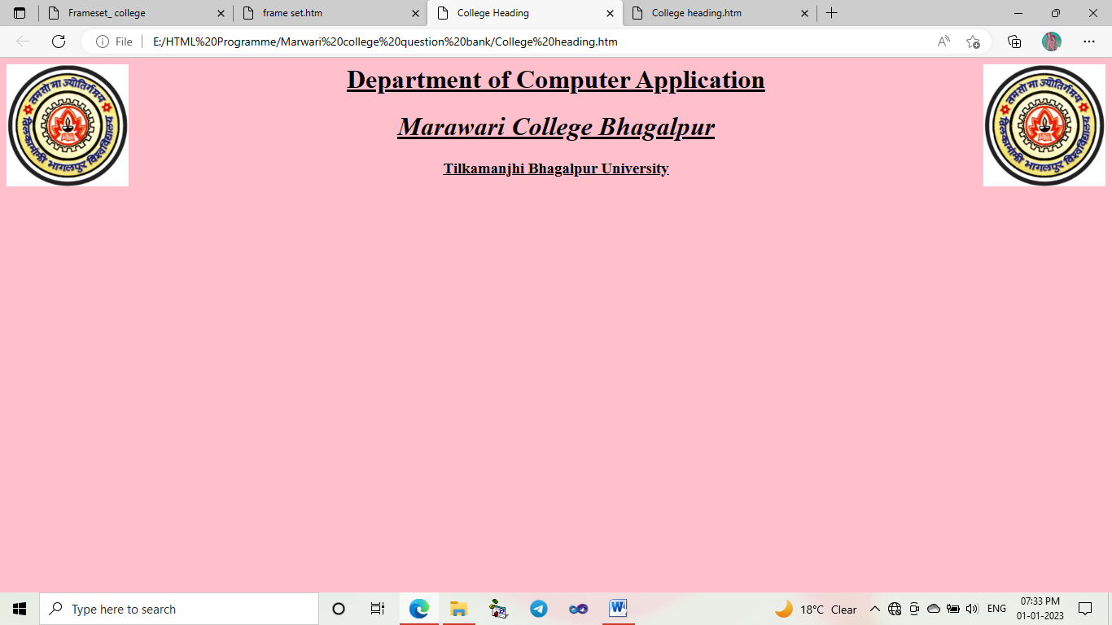

## 3. Coding and Designing of Title of Question Bank:-

|  |  |
| --- | --- |
|  | <html> |
|  | <head> |
|  | <title> Question_bank heading</title> |
|  | </head> |
|  | <body bgcolor="Red"> |
|  | <center><h1><b><i><u>Question Bank</u></i></b></h2></center> |
|  | <font size="5"><marquee scrollamount="10"><a href="<https://drive.google.com/drive/u/0/folders/1NK0o2eDXTItpQg5622GtoklzSnsGfrNB>"target=_blank> >2nd sem (Session:-2019-22) result Available Now.</a></marquee></font> |
|  | </body> |
|  | </html> |

### OUTPUT:-

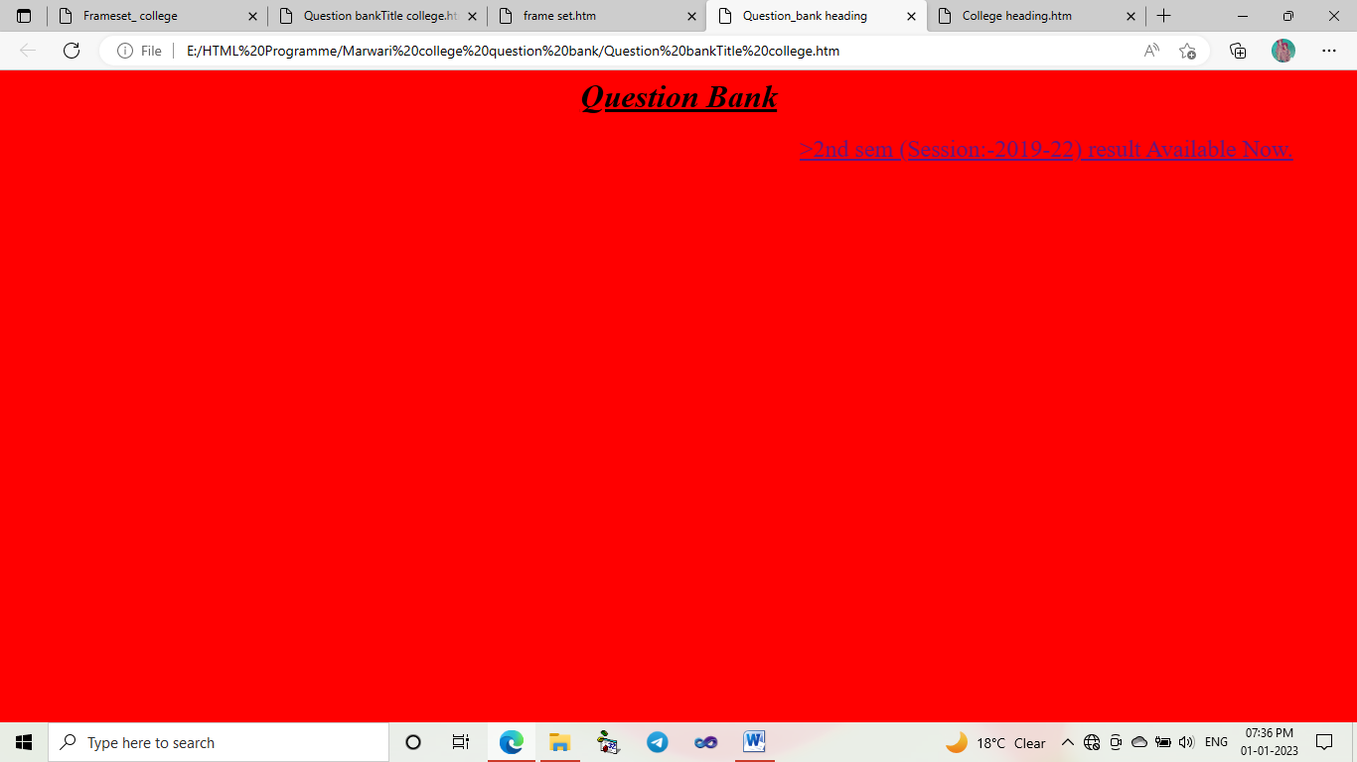

## 4. Coding and Designing of Left side Frame:-

|  |
| --- |
| <html> |
|  | <head> |
|  | <title>marquee></title> |
|  | <head> |
|  | <body bgcolor="voilet"text="White"> |
|  | <font="7"><marquee scrollamont="20" height="100%" width="100%" direction="up"> <font="6"><u><b><i>Introduction</i></b></u></font> |
|  | <br> |
|  | <br> |
|  | Marwari College,is founded in 1941,is a constituent unit (N.A.A.C. Accredited 'A' Grade) of T.M. Bhagalpur University. It occupies the foremost position among the peer colleges of the university and is acclaimed as an institution for imparting quality education in the faculties of Science, Arts and Vocational courses. Currently, this College Principal is<strong> &nbsp;<u><i>Sri K.C.Jha</i></u></strong> |
|  | <br> |
|  | <br> |
|  | Location<br> |
|  | >Campanibag, P.S:-University O.P <br> Block:-Jagdishpur<br> District:- Bhagalpur<br>Pin-code:-812004 |
|  | </marquee> |
|  | </font> |
|  | </body> |
|  | </html> |

### Output:*-*

## 5. Code and designing of right side panel / frame:-

|  |  |
| --- | --- |
|  | <html> |
|  | <head> |
|  | <title>marquee notice college></title> |
|  | <head> |
|  | <body text="Pink"> |
|  | <font="7"><marquee bgcolor="voilet" scrollamont="20" height="100%" width="100%" direction="up" behaviour="slide"> >B.C.A question bank is updated. |
|  | <br><br> >B.B.A 4th sem form fill up last date 26-08-2022. |
|  | <br><br> >First list Intermidiate (Session:-2022-24)Admission date is Extended till 25-08-2022. |
|  | </marquee> |
|  | </font> |
|  | </body> |
|  | </html> |

### Output:-

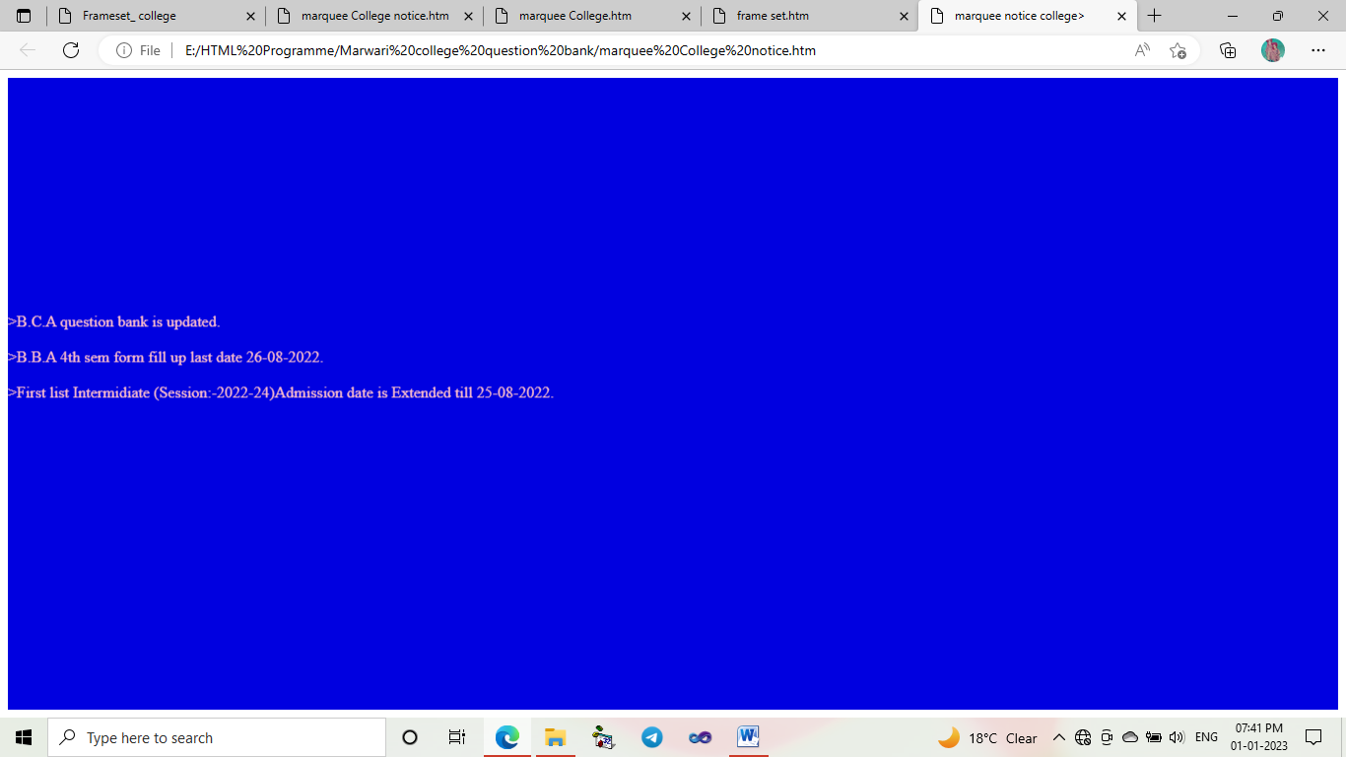

## 6. Coding and designing of Centre part , i.e BCA All semeste

|  |  |
| --- | --- |
|  | <html> |
|  | <head> |
|  | <title> developed by.... heading</title> |
|  | </head> |
|  | <body bgcolor="yellow"> |
|  |  |
|  | <center><font="7"><h1><b><i><u>BCA All Semester</u></i></b></h1></font></center> |
|  | <h2 align="Center"><b><i><u>Select your Semester</u></i></b></h2> |
|  | <font="7"> |
|  | <a href="BCA 1ST SEM SYLLABYS.htm">BCA 1<sup>st</sup> Semester</a> <br><br> |
|  | <a href="BCA 2nd SEM SYLLABYS.htm">BCA 2<sup>nd</sup> Semester </a><br><br> |
|  | <a href="BCA 3rd SEM SYLLABYS.htm">BCA 3<sup>rd</sup> Semester </a><br><br> |
|  | <a href="BCA 4th SEM SYLLABYS.htm">BCA 4<sup>th</sup> Semester</a> <br><br> |
|  | <a href="BCA 5th SEM SYLLABYS.htm">BCA 5<sup>th</sup> Semester </a><br><br> |
|  |  |
|  | <a href="BCA 6th SEM SYLLABYS.htm">BCA 6<sup>th</sup>Semester</a> <br><br> |
|  | </font> |
|  | </body> |
|  | </html> |

### Output:-

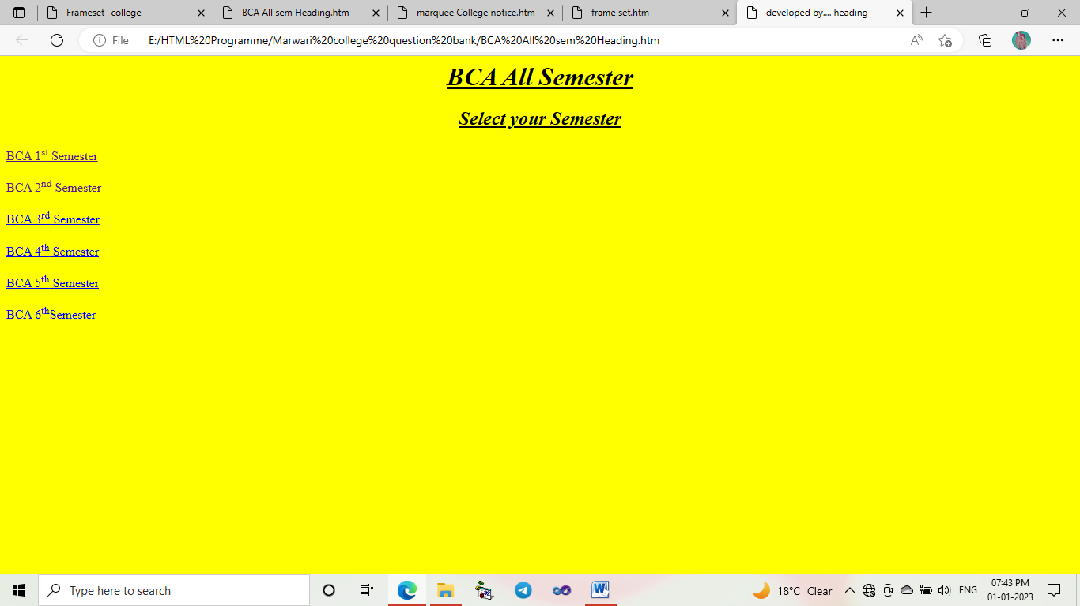

# 7. Coding and designing of Footer section frame:-

|  |
| --- |
| <html> |
| <head> |
| <title> developed by.... heading</title> |
| </head> |
| <body bgcolor="Green"> |
| <center><font="7"><h2>Developed By:- <b><i><u>Mr. C.K. Chiranjivi</u></i></b></h2></font></center> |
| </body>  </html> |

### OUTPUT:-

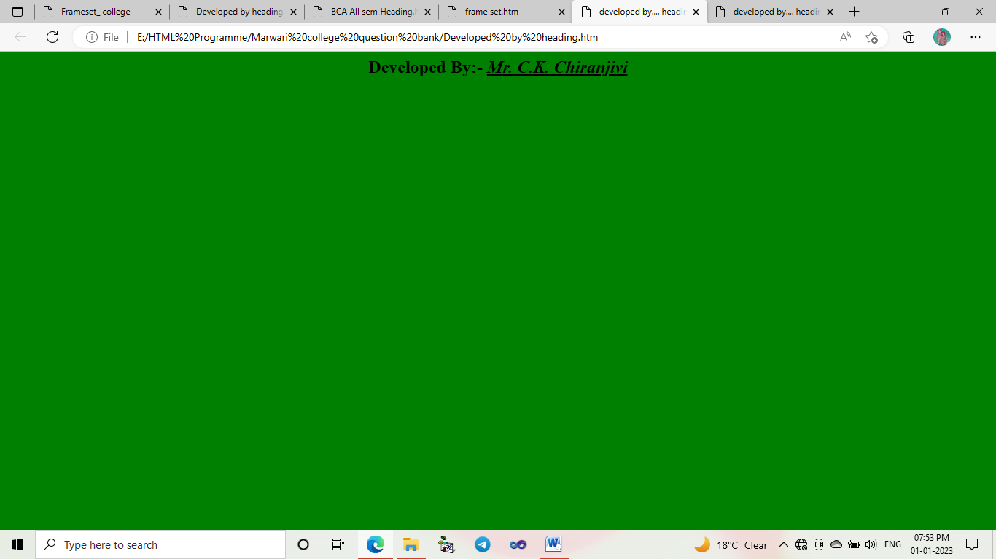

# After designing the frame section the design the inner part of this project, i.e , BCA Semester wise page designing:-

# BCA 1st semester :-

|  |
| --- |
| <html> |
|  | <head> |
|  | <title> Question_bank heading</title> |
|  | </head> |
|  | <body bgcolor="Yellow"> |
|  | <h2 align="Center"><b><i><u>Select Paper</u></i></b></h2> |
|  | <ul> |
|  | <li><a href ="Year list 1.htm">BCA-101</a></li> |
|  | <li><a href ="Year list 1.htm">BCA-102</a></li> |
|  | <li><a href ="Year list 1.htm">BCA-103</a></li> |
|  | <li><a href ="Year list 1.htm">BCA-104</a></li> |
|  | <li><a href ="Year list 1.htm">BCA-105</a></li> |
|  | <li><a href ="Year list 1.htm">BCA-106</a></li> |
|  |  |
|  | </ul> |
|  | </body> |
|  | </html> |

## Output:-

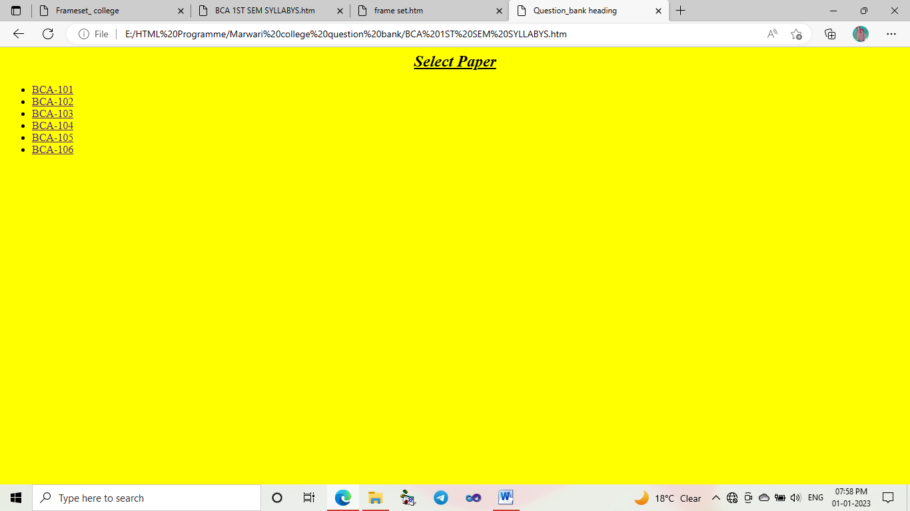

**And all Semester designing is as the follow above.**

### Then , After the Designing the above page than Year wise all Semester :-

|  |
| --- |
|  |
| <html> |
|  | <head> |
|  | <title> Question_bank heading</title> |
|  | </head> |
|  | <body bgcolor="Yellow"> |
|  | <h2 align="Center"><b><i><u>Select Year</u></i></b></h2> |
|  | <font size="5"> |
|  | <ul> |
|  | <li><a href="101.pdf">2008</a></li> |
|  | <li><a href="Question page.htm">2009</a></li> |
|  | <li><a href="Question page.htm">2010</a></li> |
|  | <li><a href="Question page.htm">2011</a></li> |
|  | <li><a href="Question page.htm">2012</a></li> |
|  | <li><a href="Question page.htm">2013</a></li> |
|  | <li><a href="Question page.htm">2014</a></li> |
|  | <li><a href="Question page.htm">2015</a></li> |
|  | <li><a href="Question page.htm">2016</a></li> |
|  | <li><a href="Question page 1.htm">2017</a></li> |
|  | <li><a href="Question page.htm">2018</a></li> |
|  | <li><a href="Question page.htm">2019</a></li> |
|  | <li><a href="Question page.htm">2020</a></li> |
|  | <li><a href="Question page.htm">2021</a></li> |
|  | <li><a href="Question page.htm">2022</a></li> |
|  | </ul> |
|  | </font> |
|  | </body> |
|  | </html> |
|  |  |

### OUTPUT:-

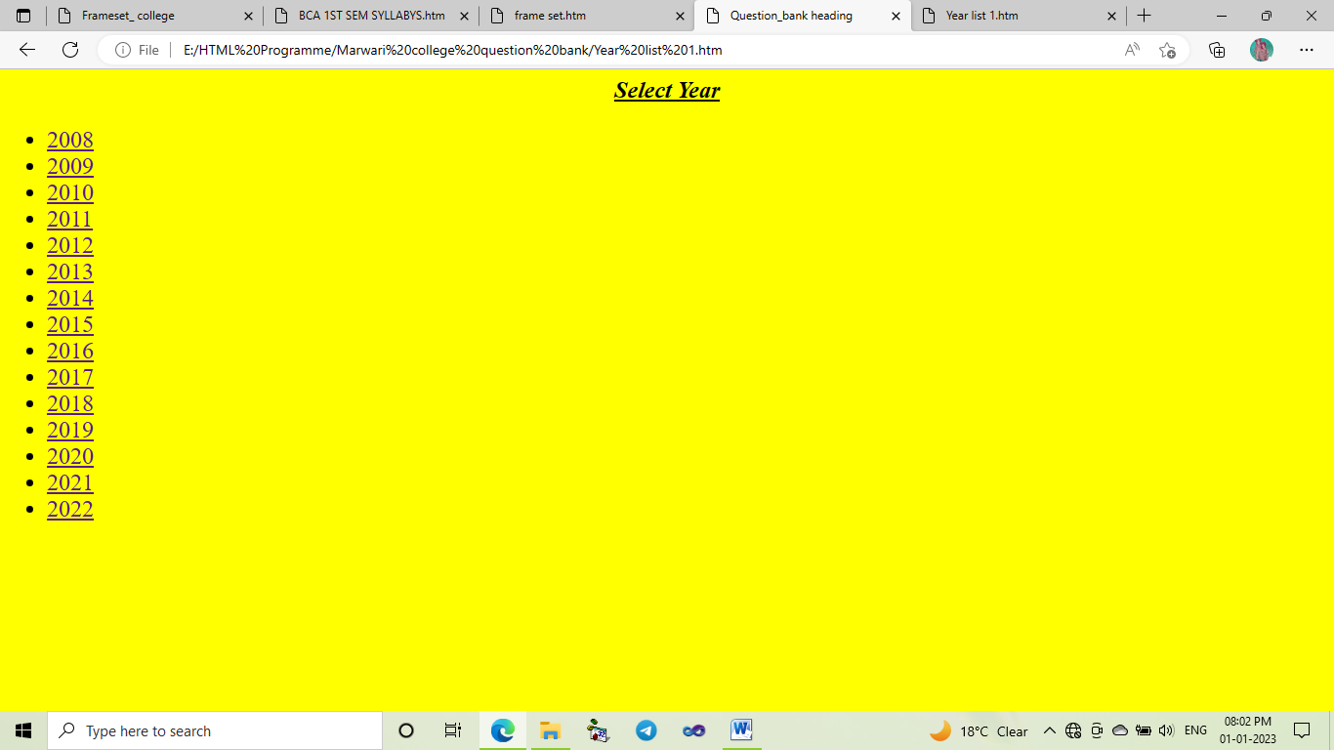

## After the designing of all semester Year listing page, than Link the specific question for year and Semester.

## OUTPUT Of clicking on Specific year and semester:-

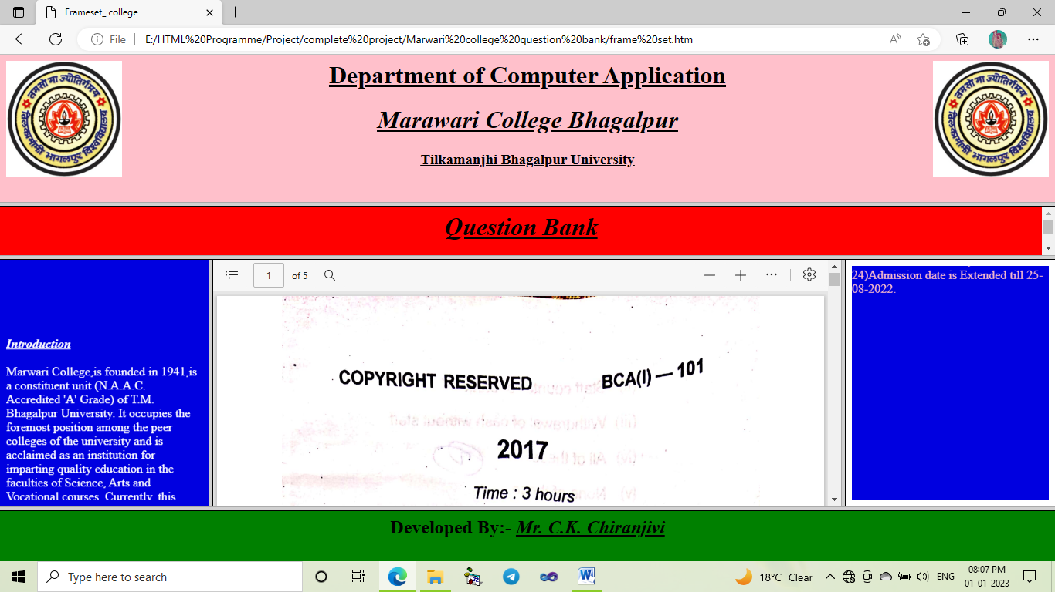

# Final OUTPUT Of our Project Question Bank:-

